**Credit card churn prediction model building**

**Introduction:** successful model building requires a combination of domain knowledge, data understanding, and creativity. It is a process that can lead to improved decision-making, problem-solving, and innovation. This introduction serves as a starting point to explore the diverse world of model building and its applications in various domains.

**Preprocessing:**

* Acquire the dataset
* Import the libraries
* Import the dataset
* Handle the missing values
* Encode the categorical data
* Split the dataset into training, validation and evaluation metrics
* 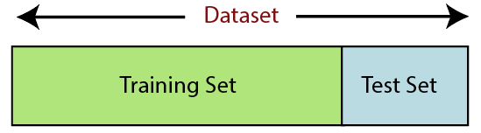Feature scaling

**Split ratio: 75:25**

**Balancing the data :** my data is imbalanced,so I need to balanced the data after preprocessing by using **SMOTE** technique.

In Oversampling Technique we have Majority sampling and minority sampling. So, we need to do Oversampling upon minority sampling, so now the number of samples is increased and now our data is balanced.

**Data Cleaning Report:**

After the completion of data cleaning, Now we are ready to send our data to Neural Network.

But, before sending our data to the neural network, we must observe our data, whether it is properly scaled or not, because our numerical data should be in the same scale then only our neural network properly works and training could be speed.

So, we must Rescale our data by using Normalisation techniques or Standardisation techniques, so the values will lie between 0 to 1.

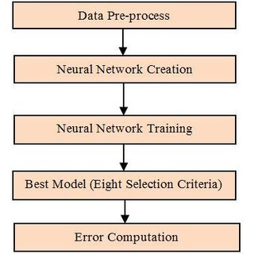This technique helps us to train our model very fast and our optimizers will run very fast.

**Model Report:**

To create the ANN Model we used the Keras Tuner. Where keras tuner can help us to return the best model corresponding to No.of.hidden layers and no.of.Neurons and which activation function to be used, which optimizer and weight initializers etc.

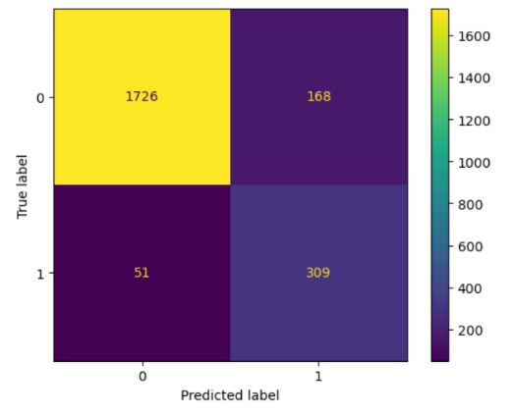Our target variable is binary classification, so we used the loss function as “binary_crossentropy”.

**Model Accuracy:**

Finally, my model accuracy is 90%.

The total hidden layers are 5, activation is relu, optimizer is rmsprop.